Module :-

1. **Max Retry Module:-**

-> This Module used to set the maximum attempt of non- connecting Auto Call on the basis of Priority and campaign. This module will be used for only Auto Dial.

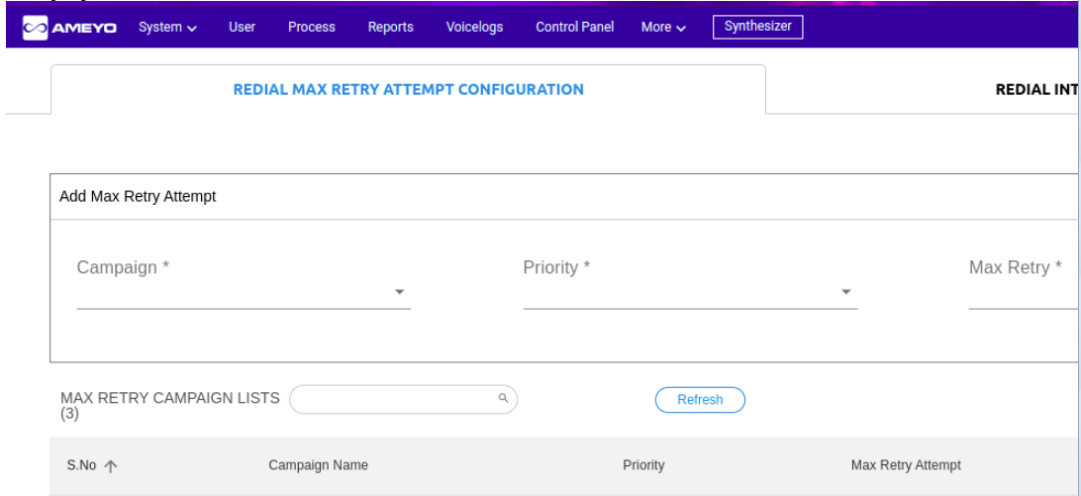

Eg:- Campaign_name | Priority | Max_Attempt

Mumbai_Priority2 |2 | 5

Based on the above data record the customer of campaign mumbai_priority2 with priority 5 will be dialed 5 times through Auto Dial.

1. **Retry Interval Module**

-> This Module used to set the retry time of Auto non- connected Calls.This module will be used for only Auto Dial.

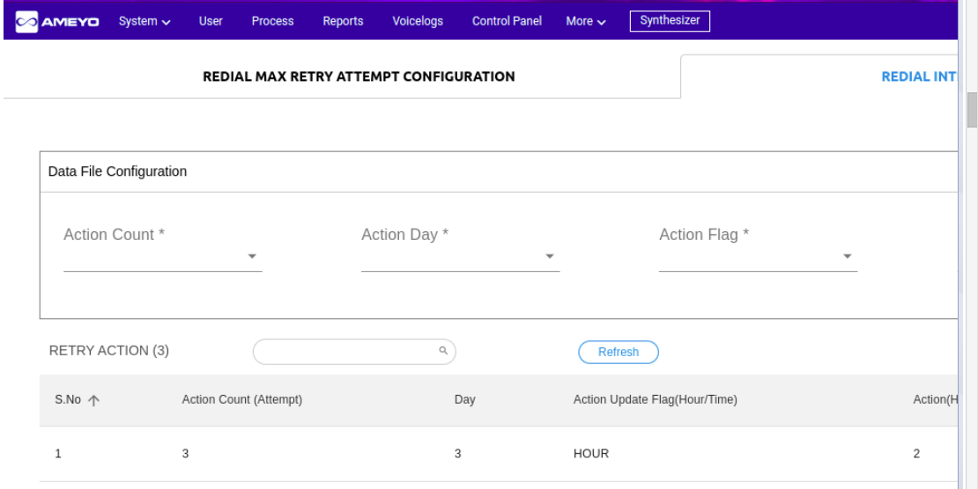

Suppose dialed time of any call is "2023/07/01 12:00:00 +0530";

Eg:- Action_Count | Action_Day | Action_Flag| Retrt_Time

2 | 1 | TIME |00:25:00

3 |2 | Hour |01:00:00

Action count is attempt of call(for auto dial we are counting attempt value)

a.Based on the first above data record the second attempt of a non-connected customer will be dialed on the same day (day 1) after 25 minutes through Auto Dial.

b. Based on the second above data record the third attempt of a non-connected customer will be dialed on the second day (day 2) 1 PM through Auto Dial. dialtime update

1. **Lead Migration Module(disposition_config module):-**

Customer upload via salesforce in ameyo through CM API in New lead. This module migrates customers from New lead to Score lead on the basis of user disposition.

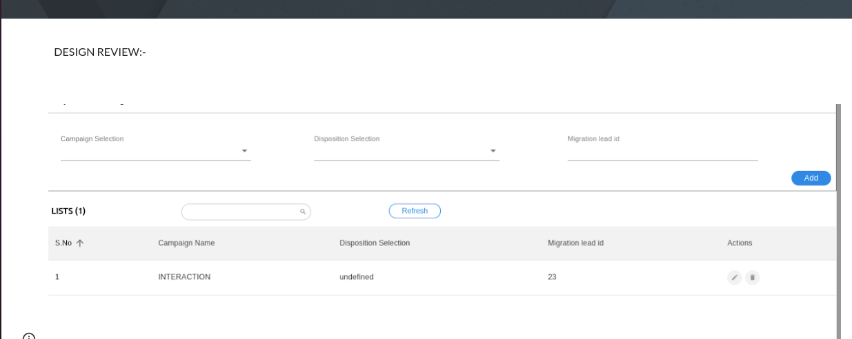

Eg:- Campaign_name | Disposition Selection | Migration Lead id

Lucknow_HSPL | Follow up_Callback | 1650

a.Based on the above data record the customer having disposition code Follow up_Callback will be migrated to lead id 1650.

Note:- All module used for auto dial only

**Data Table Structure:-(Lms_leadno is primary key)**

__customer_id | 719023520

timezone |

priority_flag | 4

phone2 | null

phone3 | null

phone1 | 7016531949

branch_cd | 305

lms_leadno | 00Q72000007PgZWEA0

keyval11 | 22.0

keyval12 | 0

keyval10 | 4

keyval15 | MORTGAGE

keyval13 | 0

keyval14 | 0

keyval6 | null

keyval7 | 1

keyval8 |

agentid | 0058n000000VTQ6AAO

keyval9 | 232.0000

keyval2 | NA

keyval3 | HSPLRetryMaxAttempts

keyval4 | NA

keyval5 | HDFC SALES

dnc_check | true

dialtime | 2023-03-30 07:07:16

name | Amit Amit

keyval1 | INT_REF

active_ind | Y

should_dial | t

numattempts |1

migrated_lead_id | 2345677

->The numattempts field in the data table is used to store the total number of auto calls. If the auto call is connected then the value of this field will again change to "0" otherwise it will be auto incremented for non-connected.

**table filter:-**

dialtime::timestamp::text >= ''||now()||'' AND active_ind='Y'

**Auto Dial Flow:-**

Previously the format of lms_leadno was numeric. Now the value of this ID is converted to alphanumeric for the same customer in Salesforce.

Pre Processing Nodeflow :- Before dialing any customer, ameyo checks whether the lms_leadno of that customer is alphanumeric or not. If the value is alphanumeric then auto calling starts but If the value is numeric then ameyo call a salesforce api to get the alphanumeric (salesforce lms_leadno) value of that customer and then it create a new record using alphanumeric lms_leadno of same customer and update the old record as active_ind “N” and should_dial “F” and stop the dialing. Now, the same customer will dial with new lms_leadno

**Stage 2.**

Auto Dial Nodeflow :- Once Pre- Processing nodeflow executes and auto dial nodeflow starts, ameyo system starts dialing customers before dialing customer ameyo check the dialing policy condition defined in the nodeflow on the basis of threshold value and dnc_check value. Threshold value decided from hdfc existing module and dnc check from data table.After the call connected a salesforce API call to change the lead owner of salesforce and then the CRM page(lead page or CTI) pop-up and call recording start.

**Stage 3.**

Post processing :-

After Call dispose post processing nodeflow execute. The post processing nodeflow will read the configuration of lead migration module , max_attempt module and retry interval module and change the value accordingly of customer in ameyo database and also send the calling details to salesforce through reverse feed. **Max Retry and retry interval module used for auto dial only.**

**->Next Action (Retry Time)Update Conditions for auto dial:-**

**n**

In the post processing max attempt and next action(retry time) read out from the module and update the data table accordingly.

1) If the dispostionClass of that call is schedule.callback then next action (dialtime) will be callback time chosen by agent and same will update in ameyo database and pass the data to salesforce via reverse feed api.

2) If the dispositionClass is force.dispo it means the agent has not scheduled any callback then the customer will dial via auto dial only and in this case next action will be the time defined in the module.

**->Active_Ind Value Update Conditions for manual dial:-**

Default value of active_ind is “Y”

1.If the value of numattempts is greater than max_attempt defined in max _ attempt module then the value of active_ind will change to “N” it means the customer will not dial again via auto dial.

1. Active_ind value changes from “Y” to “N” when an agent disposes of any call using a “closed” disposition code.

2.Active_ind value changes from “Y” to “N” when an agent disposes of any call using a “force.dispo” disposition class.

Note:- If the value of Active_ind is “Y” then only auto.dial will work.

**-> dispositionCode Value update condition in salesforce.**

In the case of an auto dial (predictive) customer connects first and if the call is not connected then call will not come to an agent and in this case disposition code will be null for this case disposition code value is hardcoded and the same value will push in the salesforce via reverse feed.

1. If the active_ind of that customer is “Y” and call is not connected then dispositionCode will be “Follow Up-CALL_BACK-null”
2. If the active_ind of that customer is “N” and call is not connected then dispositionCode will be “Closed-NO_ANS-null”

**->Through post processing we also change the status of the call to NOT_TRIED as per the condition defined below.**

Ameyo also change the lead status as not tried on the basis of below mentioned cases:-

**Lead Status Change:-**

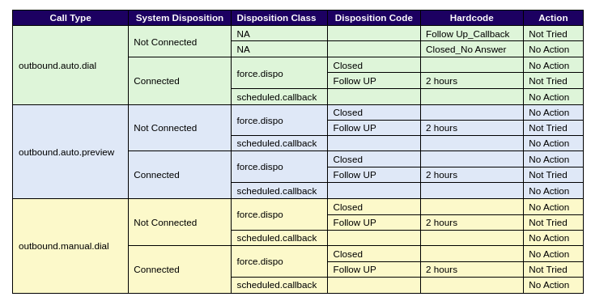

**NOTE:- In the above chart the hardcode value of 2 hours has been removed from the nodeflow**

**Case 1:- Call_Type(outbound.auto.dial)--> Predictive**

**A)Not Connected:-**

**a)Follow up_Callback**

->If system disposition is Not Connected and User Disposition (disposition code) is Follow up_Callback then Lead Status (system disposition) should be changed to NOT_TRIED.

Eg. If the customer dialed through outbound.auto.dial and system disposition is No_Answer and disposition Code is Follow up_Callback then Lead status should be changed from No_Answer to NOT_TRIED.

**b)Closed_No Answer**

->If system disposition is Not Connected and User Disposition (disposition code) is Closed_No Answer then Lead Status (system disposition) should not be changed.

Eg. If the customer dialed through outbound.auto.dial and system disposition is No_Answer and disposition Code is Closed_No Answer then Lead status should not be changed it will be the same as No_Answer.

**A)Connected:-**

**a)force.dispo(closed)**

->If system disposition is Connected ,User Disposition Class (disposition class) is force.dispo and disposition code is closed then Lead Status (system disposition) should not be changed.

Eg. If the customer dialed through outbound.auto.dial and system disposition is CONNECTED ,User Disposition Class (disposition class) is force.dispo and disposition Code is close then Lead status should not be changed.

**a)force.dospo(follow -up)**

->If system disposition is Connected ,User Disposition Class (disposition class) is force.dispo and disposition code is follow-up then Lead Status (system disposition) should be changed to NOT_TRIED.

Eg. If the customer dialed through outbound.auto.dial and system disposition is BUSY and disposition Code is Follow up_Callback then Lead status should be changed from BUSY to NOT_TRIED.

**Case 2:- Call_Type(outbound.auto.preview)-->**

**A)Not Connected:-**

**a)Follow up_Callback**

->If system disposition is Not Connected and User Disposition (disposition code) is Follow up_Callback then Lead Status (system disposition) should be changed to NOT_TRIED.

Eg. If the customer dialed through outbound.auto.dial and system disposition is No_Answer and disposition Code is Follow up_Callback then Lead status should be changed from No_Answer to NOT_TRIED.

**b)Closed_No Answer**

->If system disposition is Not Connected and User Disposition (disposition code) is Closed_No Answer then Lead Status (system disposition) should not be changed.

Eg. If the customer dialed through outbound.auto.dial and system disposition is No_Answer and disposition Code is Closed_No Answer then Lead status should not be changed it will be the same as No_Answer.

**A)Connected:-**

**a)force.dispo(closed)**

->If system disposition is Connected ,User Disposition Class (disposition class) is force.dispo and disposition code is closed then Lead Status (system disposition) should not be changed.

Eg. If the customer dialed through outbound.auto.dial and system disposition is CONNECTED ,User Disposition Class (disposition class) is force.dispo and disposition Code is close then Lead status should not be changed.

**a)force.dospo(follow -up)**

->If system disposition is Connected ,User Disposition Class (disposition class) is force.dispo and disposition code is follow-up then Lead Status (system disposition) should be changed to NOT_TRIED.

Eg. If the customer dialed through outbound.auto.dial and system disposition is BUSY and disposition Code is Follow up_Callback then Lead status should be changed from BUSY to NOT_TRIED.